

[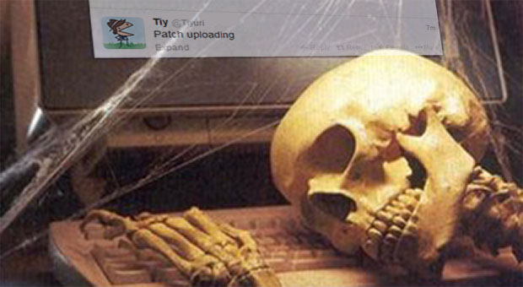](https://www.google.com.au/url?sa=i&rct=j&q=&esrc=s&source=images&cd=&cad=rja&uact=8&ved=0ahUKEwiKusbpp_LLAhUDMaYKHaVHBFkQjRwIBw&url=https://www.reddit.com/r/starbound/comments/1sj44g/patiently_waiting/&psig=AFQjCNEUr21a0k_AQZRkZVPx0pkTX-h94A&ust=1459767494452703)

[](http://thefunnyplace.org/wp-content/uploads/2014/01/Waiting-patiently.jpg)